**HW1 MATLAB code**

2.

% f(t)

a0 = 0;

t = linspace(-3,4,1000);

T = 2;

f = a0*ones(1,length(t));

for n = 1:20

an = 0;

bn = 2/(n*pi)*(1-(-1)^n);

f = f + an*cos(2*pi*n.*t/T) + bn*sin(2*pi*n.*t/T);

end

f_true = square(pi*t);

overshoot_f = (max(abs(f))-1)/2;

figure(1);

plot(t,f,'--',t,f_true);

title('f(t) (n=20)');

xlabel('t'); ylabel('f(t)');

axis([-3 4 -2 2]);

legend('Fourier series', 'True function')

% g(t)

a0 = 0;

t = linspace(-5*pi,5*pi,1000);

T = 2*pi;

g = a0*ones(1,length(t));

for n = 1:50

an = 0;

bn = -2/n*(-1)^n;

g = g + an*cos(2*pi*n.*t/T) + bn*sin(2*pi*n.*t/T);

end

g_true = pi*sawtooth(t-pi);

overshoot_g = (max(abs(g))-pi)/(2*pi);

figure(2);

plot(t,g,'--',t,g_true);

title('g(t) (n=50)');

xlabel('t'); ylabel('g(t)');

axis([-5*pi 5*pi -10 10]);

legend('Fourier series', 'True function')

% h(t)

a0 = 0.5;

t = linspace(-3,3,1000);

T = 2;

h = a0*ones(1,length(t));

for n = 1:10

an = 2*(1-(-1)^n)/(n*pi)^2;

bn = 0;

h = h + an*cos(2*pi*n.*t/T) + bn*sin(2*pi*n.*t/T);

end

h_true = -0.5*sawtooth(pi*t,1/2) + 0.5;

figure(3);

plot(t,h,'--',t,h_true);

title('h(t) (n=10)');

xlabel('t'); ylabel('h(t)');

axis([-3 3 -1 2]);

legend('Fourier series', 'True function')

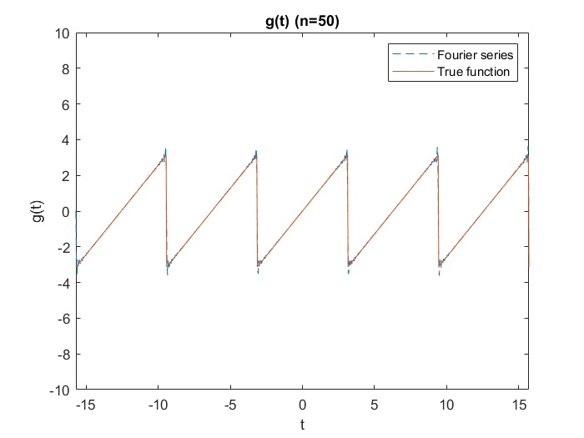

4.

f = linspace(-1.5,1.5,500);

f0 = 1;

for N = [3 5 10 30]

H = sin(pi*(2*N+1)*f/f0)./sin(pi*f/f0);

figure(find([3 5 10 30]==N));

plot(f,H);

title(sprintf('N = %d', N));

xlabel('f'); ylabel('H(f)');

end

